Module 05 Course Project – Adding Forms and Storing Values

Tracy Brevig

Rasmussen College

COURSE#: W110/COP1801 Section 01 Javascript

Instructor’s Name: Kimberly Powell

March 14, 2021

**Screenshots of the loaded page:**

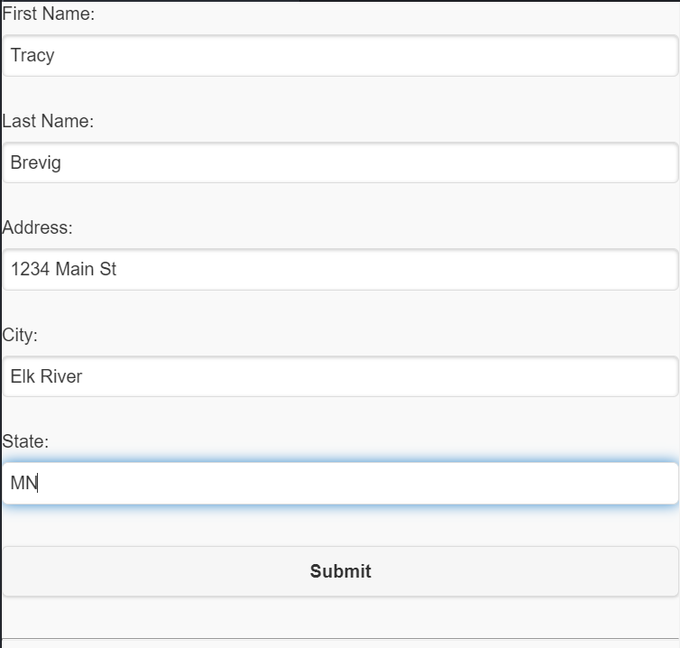

**After you hit submit results are displayed:**

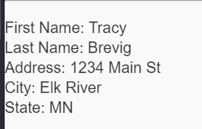

URL Link

<http://sotd.us/tracybrevig/index5.1.html>

Git Hub URL

<https://github.com/tbrevig/COP1801_Javascript/blob/main/Module_05/Project/index5.1.html>